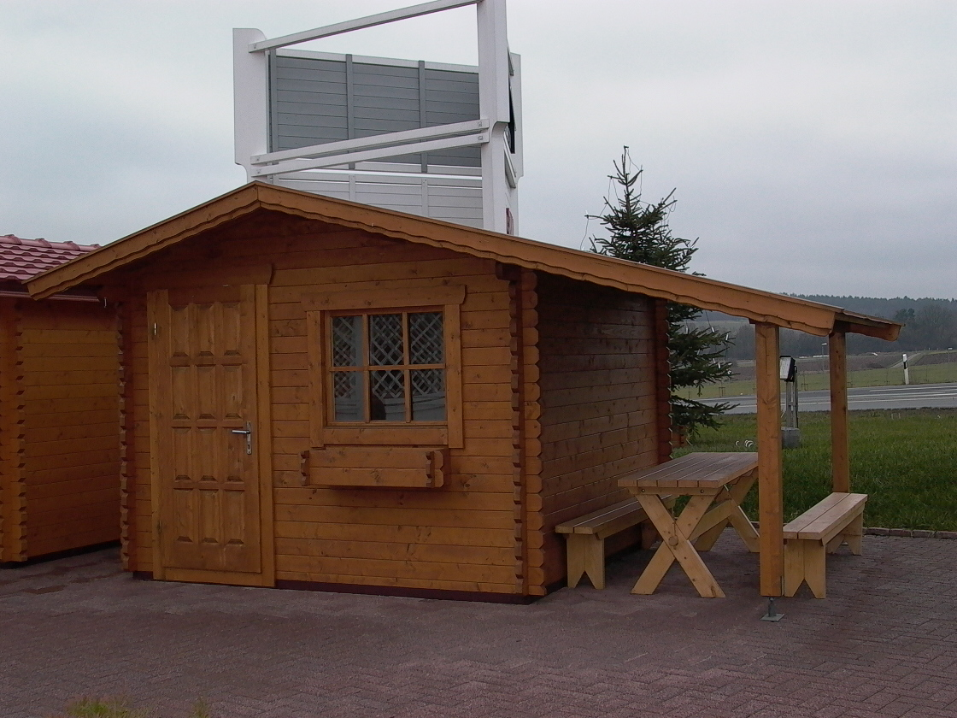 | 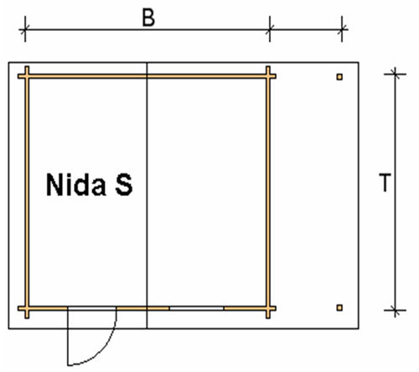
 | 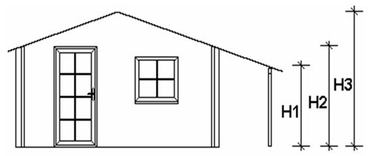

Nida-S Log Cabin
Roof projection: Front 0.70 m
Back 0.20 m
Side 0.30 m
Consists of:
Walls: 45 mm or (60 mm glued) double tongue and groove logs from Northern Pine
Floor: 20 mm tongue and groove floor boards on the impregnated base frame
Roof: 20 mm tongue and groove roof boards on the roof beams
Door: 1 glued cartridge door 90/196 with seal
Windows: 1 double-glazed 80/94 tilt ‘n‘ turn unit
Shelter: Height of shelter supports (H1=1.64 m)

Size (m) |  |  | Log Cabin Height (m) |  |  | Price (£) |  | Optional Extras
Cabin |  | Shelter |  |  |  |  |  | Roof Insulation (£) |  | Shingles (£)
B | T | C | H1 | H2 | H3 | 45 | 60 | 45 | 60 | Shingles (£)
3.0 | 3.0 | 1.5 | 1.64 | 2.08 | 2.50 | 2114 | - | 90 | - | 146
3.0 | 4.0 | 1.5 | 1.64 | 2.08 | 2.50 | 2520 | - | 108 | - | 170
4.0 | 3.0 | 1.5 | 1.64 | 2.08 | 2.63 | 2520 | - | 108 | - | 170
4.0 | 4.0 | 1.5 | 1.64 | 2.08 | 2.63 | 2914 | 3622 | 130 | 132 | 170
4.0 | 5.0 | 1.5 | 1.64 | 2.08 | 2.63 | 3232 | 4019 | 147 | 149 | 243
5.0 | 4.0 | 1.5 | 1.64 | 2.08 | 2.70 | 3263 | 4019 | 152 | 154 | 243
5.0 | 5.0 | 1.5 | 1.64 | 2.08 | 2.70 | 3612 | 4578 | 172 | 173 | 275

Extras:

Single window £83
Double window 1200/940 £124
Single door £159
Double door 1700/1970 £267

